**Experiment no. 2: To implement selection sort and Comparative analysis for large values of ‘n’.**

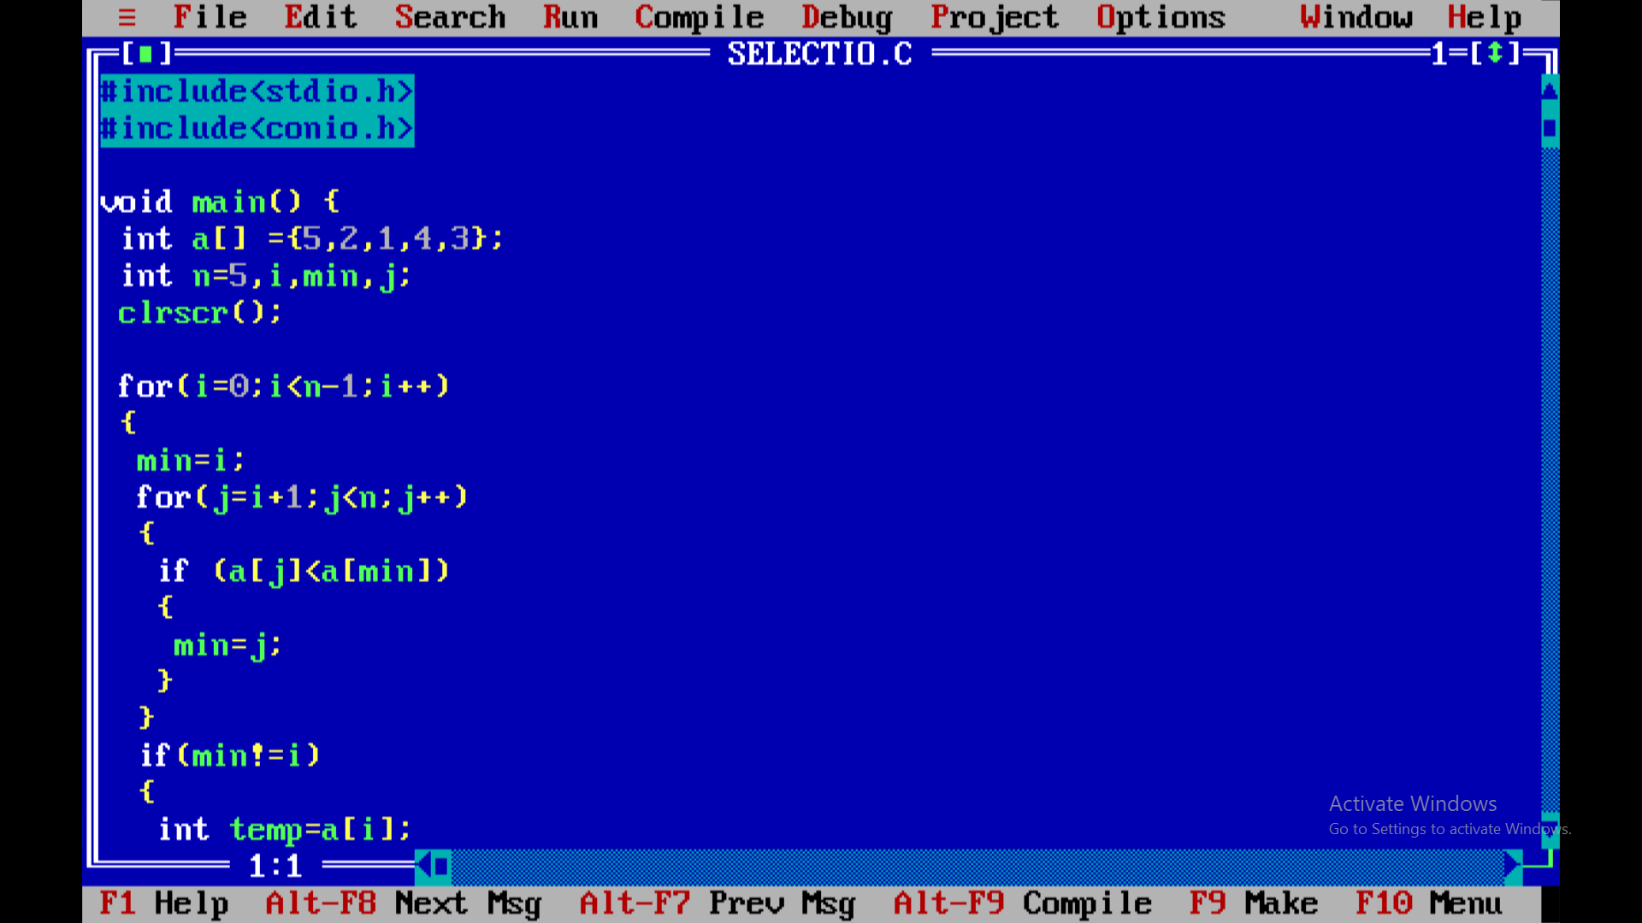

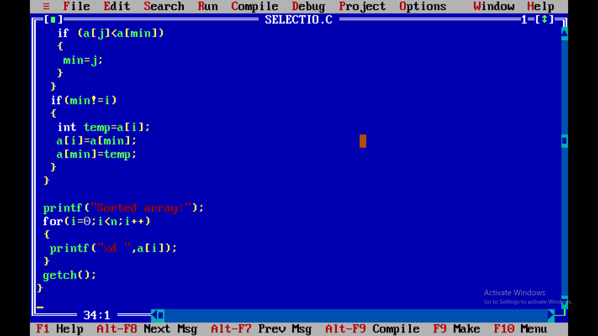

**Output:**

